* Create table

package com.cdac_24_march;

import java.sql.Connection;

import java.sql.DriverManager;

import java.sql.SQLException;

import java.sql.Statement;

public class Create_Table {

public static void main(String[] args) {

// load the class

try {

Class.forName("com.mysql.cj.jdbc.Driver");

// get the connection

Connection con = DriverManager.getConnection("jdbc:mysql://localhost:3306/pune?useSSL=false", "root",

"cdac");

// create the statement

Statement s = con.createStatement();

// create query

String q1 = "create table ClassMates3(" + "Student_id int primary key,"

+ "Student_name varchar(20) not null," + "Student_age int not null,"

+ "Student_gender varchar(10) not null," + "Student_mobile_number varchar(10) not null,"

+ "Student_city varchar(20) not null " + ");";

int i = s.executeUpdate(q1);

System.out.println(i);

//close statement

s.close();

// close connection

con.close();

} catch (ClassNotFoundException | SQLException e) {

e.printStackTrace();

}

System.out.println("Table created sucsefully");

}

}

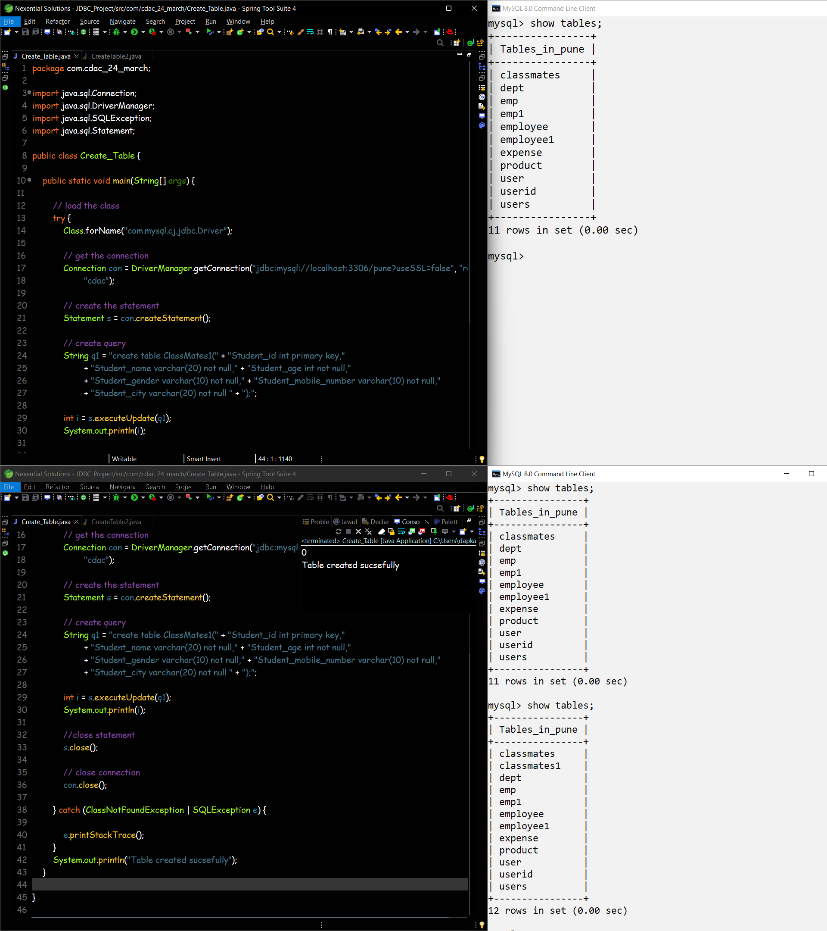

* INSERT row into the table

package com.cdac_24_march;

import java.sql.Connection;

import java.sql.DriverManager;

import java.sql.SQLException;

import java.sql.Statement;

public class Insert_Table {

public static void main(String[] args) {

try {

// load the class

Class.forName("com.mysql.cj.jdbc.Driver");

// create the connection

Connection con = DriverManager.getConnection("jdbc:mysql://localhost:3306/pune?useSSL=false", "root",

"cdac");

// create query statement

Statement s = con.createStatement();

// Execute the insert query

int i = s.executeUpdate(

"insert into ClassMates1 values" + "(1,'Dnyaneshwar',25,'male',7721070240,'Ambajogai')");

System.out.println(i);

if (i > 0) {

System.out.println("Data inserted sucsefully");

} else {

System.out.println("Data insertion failed");

}

// close the statement

s.close();

// close the connection

con.close();

} catch (ClassNotFoundException | SQLException e) {

e.printStackTrace();

}

}

}

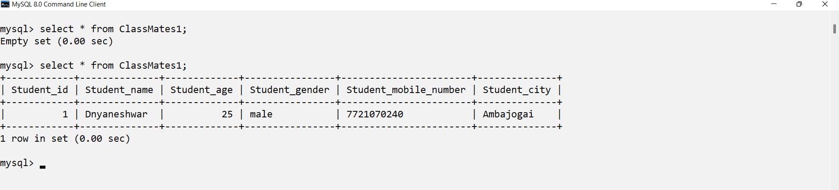

* INSERT row getting data from user using scanner

package com.cdac_24_march;

import java.sql.Connection;

import java.sql.DriverManager;

import java.sql.SQLException;

import java.sql.Statement;

import java.util.Scanner;

public class Insert_Table2 {

public static void main(String[] args) {

Scanner sc = new Scanner(System.in);

System.out.println("Enter no of records you want to insert : ");

int records = sc.nextInt();

System.out.println("Enter your Student id");

int Student_id = sc.nextInt();

System.out.println("Enter your Student name");

String Student_name = sc.next();

System.out.println("Enter your Student age");

int Student_age = sc.nextInt();

System.out.println("Enter your Student gender");

String Student_gender = sc.next();

System.out.println("Enter your Student mobile number");

int Student_mobile_number = sc.nextInt();

System.out.println("Enter your Student city");

String Student_city = sc.next();

try {

// load the class

Class.forName("com.mysql.cj.jdbc.Driver");

// create the connection

Connection con = DriverManager.getConnection("jdbc:mysql://localhost:3306/pune?useSSL=false", "root",

"cdac");

// create query statement

Statement s = con.createStatement();

// Execute the query

String q1 = "insert into ClassMates2 values(" + "'" + Student_id + "', " + "'" + Student_name + "', " + "'"

+ Student_age + "', " + "'" + Student_gender + "'," + " '" + Student_mobile_number + "'," + "'"

+ Student_city + "'" + ")";

for(int i = 1 ; i<= records; i++) {

int x = s.executeUpdate(q1);

if (x > 0)

System.out.println("Data added Successfully");

else

System.out.println("Data adding Failed");

}

// close the statement

s.close();

// close the connection

con.close();

} catch (ClassNotFoundException | SQLException e) {

e.printStackTrace();

}

sc.close();

}

}

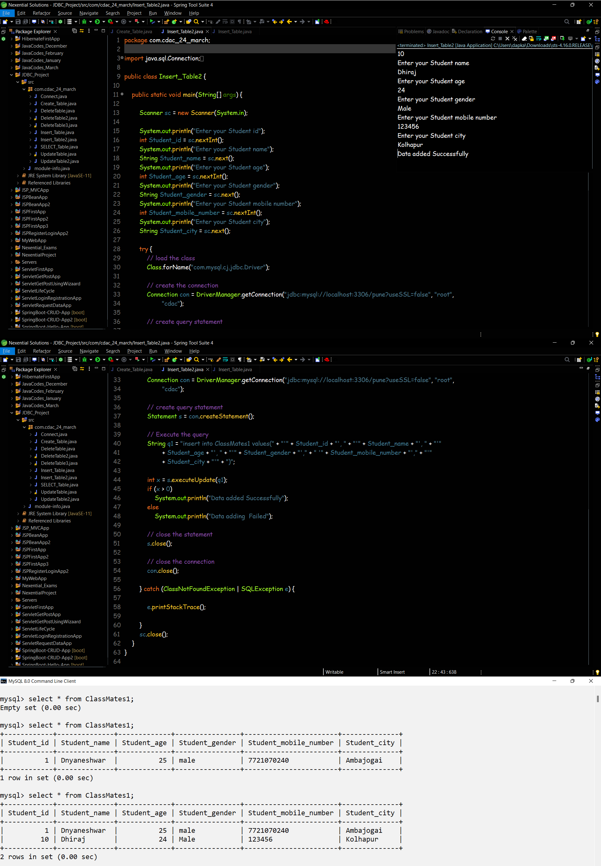

* INSERT 'n' row into the table

package com.cdac_24_march;

import java.sql.Connection;

import java.sql.DriverManager;

import java.sql.SQLException;

import java.sql.Statement;

import java.util.Scanner;

public class Insert_Table3 {

public static void main(String[] args) {

Scanner sc = new Scanner(System.in);

System.out.println("Enter your Student id");

int Student_id = sc.nextInt();

System.out.println("Enter your Student name");

String Student_name = sc.next();

System.out.println("Enter your Student age");

int Student_age = sc.nextInt();

System.out.println("Enter your Student gender");

String Student_gender = sc.next();

System.out.println("Enter your Student mobile number");

int Student_mobile_number = sc.nextInt();

System.out.println("Enter your Student city");

String Student_city = sc.next();

try {

// load the class

Class.forName("com.mysql.cj.jdbc.Driver");

// create the connection

Connection con = DriverManager.getConnection("jdbc:mysql://localhost:3306/pune?useSSL=false", "root",

"cdac");

// create query statement

Statement s = con.createStatement();

// Execute the query

String q1 = "insert into ClassMates1 values(" + "'" + Student_id + "', " + "'" + Student_name + "', " + "'"

+ Student_age + "', " + "'" + Student_gender + "'," + " '" + Student_mobile_number + "'," + "'"

+ Student_city + "'" + ")";

int x = s.executeUpdate(q1);

if (x > 0)

System.out.println("Data added Successfully");

else

System.out.println("Data adding Failed");

// close the statement

s.close();

// close the connection

con.close();

} catch (ClassNotFoundException | SQLException e) {

e.printStackTrace();

}

sc.close();

}

}

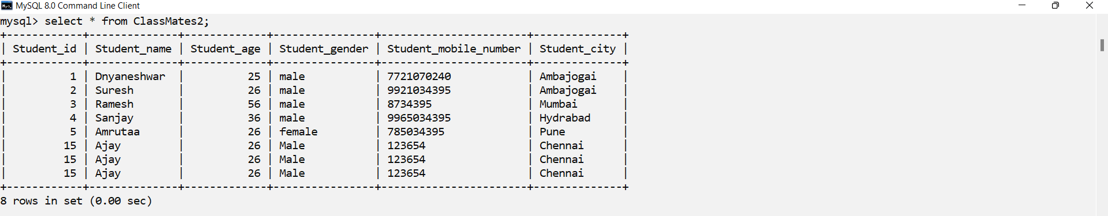

* DELETE all rows

package com.cdac_24_march;

import java.sql.Connection;

import java.sql.DriverManager;

import java.sql.SQLException;

import java.sql.Statement;

import java.util.Scanner;

public class DeleteTable3 {

public static void main(String[] args) {

Scanner sc = new Scanner(System.in);

System.out.println("Enter the id you want to delete");

int Student_id = sc.nextInt();

try {

// load the class

Class.forName("com.mysql.cj.jdbc.Driver");

// create the connection

Connection con = DriverManager.getConnection("jdbc:mysql://localhost:3306/pune?useSSL=false", "root",

"cdac");

// create query statement

Statement s = con.createStatement();

// Deleting database

String q3 = "DELETE from ClassMates1 WHERE Student_id = '" + Student_id + "'";

int x = s.executeUpdate(q3);

if (x > 0)

System.out.println("Data Successfully deleted");

else

System.out.println(" Data deleting Failed");

// close the statement

s.close();

// close the connection

con.close();

} catch (ClassNotFoundException | SQLException e) {

e.printStackTrace();

}

sc.close();

}

}

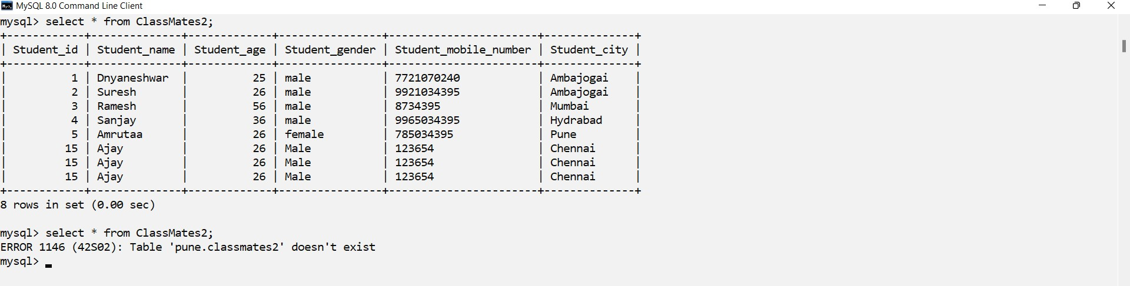

* DELETE row based on condition

package com.cdac_24_march;

import java.sql.Connection;

import java.sql.DriverManager;

import java.sql.SQLException;

import java.sql.Statement;

public class DeleteTable {

public static void main(String[] args) {

try {

// load the class

Class.forName("com.mysql.cj.jdbc.Driver");

// create the connection

Connection con = DriverManager.getConnection("jdbc:mysql://localhost:3306/pune?useSSL=false", "root",

"cdac");

// create query statement

Statement s = con.createStatement();

// Deleting database

String q3 = "DELETE from ClassMates1 WHERE Student_id = '" + "5858" + "'";

int x = s.executeUpdate(q3);

if (x > 0)

System.out.println("Data Successfully deleted");

else

System.out.println(" Data deleting Failed");

// close the statement

s.close();

// close the connection

con.close();

} catch (ClassNotFoundException | SQLException e) {

e.printStackTrace();

}

}

}

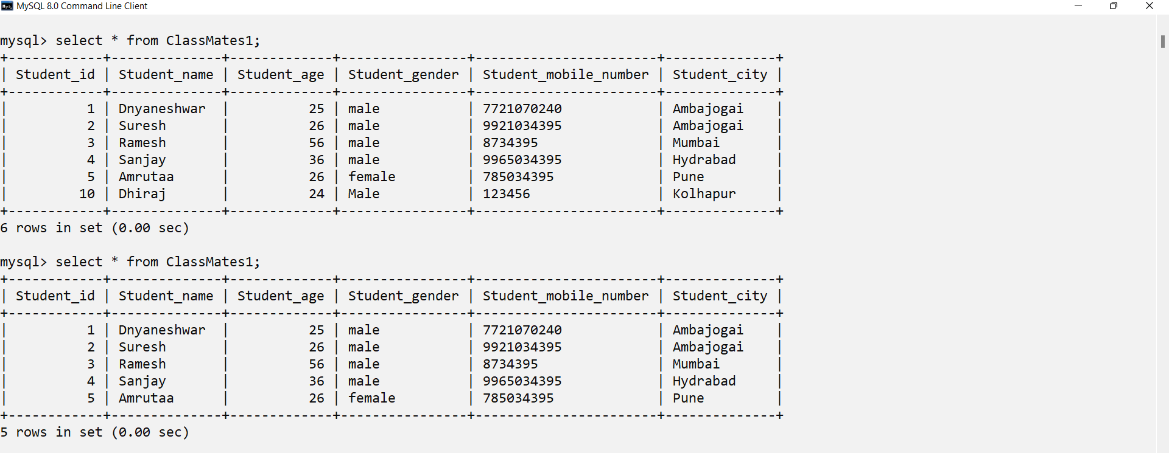

* DELETE row based on getting data from user using scanner

package com.cdac_24_march;

import java.sql.Connection;

import java.sql.DriverManager;

import java.sql.SQLException;

import java.sql.Statement;

public class DeleteTable2 {

public static void main(String[] args) {

try {

// load the class

Class.forName("com.mysql.cj.jdbc.Driver");

// create the connection

Connection con = DriverManager.getConnection("jdbc:mysql://localhost:3306/pune?useSSL=false", "root",

"cdac");

// create query statement

Statement s = con.createStatement();

// Deleting database

String q5 = "Drop table ClassMates2";

int x = s.executeUpdate(q5);

// close the statement

s.close();

// close the connection

con.close();

} catch (ClassNotFoundException | SQLException e) {

e.printStackTrace();

}

System.out.println("Data Successfully deleted");

}

}

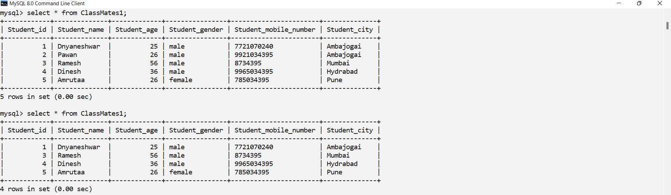

* UPDATE row based on condition

package com.cdac_24_march;

import java.sql.Connection;

import java.sql.DriverManager;

import java.sql.SQLException;

import java.sql.Statement;

import java.util.Scanner;

public class Update_Table {

public static void main(String[] args) {

try {

// load the class

Class.forName("com.mysql.cj.jdbc.Driver");

// create the connection

Connection con = DriverManager.getConnection("jdbc:mysql://localhost:3306/pune?useSSL=false", "root",

"cdac");

// create query statement

Statement s = con.createStatement();

// Updating database

String q2 = "UPDATE ClassMates1 set Student_mobile_number = '" + "8696810" + "' WHERE Student_id = '" + "5" + "'";

int x = s.executeUpdate(q2);

if (x > 0)

System.out.println("Data Successfully Updated");

else

System.out.println(" Data updating Failed");

// close the statement

s.close();

// close the connection

con.close();

} catch (ClassNotFoundException | SQLException e) {

e.printStackTrace();

}

}

}

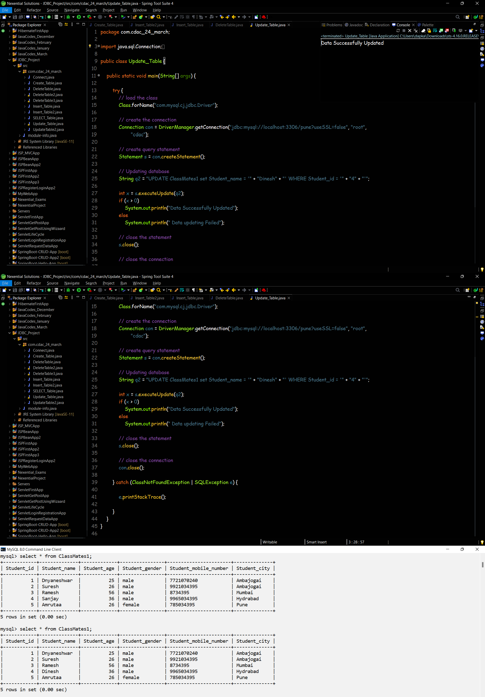

* UPDATE row based on  getting data from user using scanner

package com.cdac_24_march;

import java.sql.Connection;

import java.sql.DriverManager;

import java.sql.SQLException;

import java.sql.Statement;

import java.util.Scanner;

public class UpdateTable2 {

public static void main(String[] args) {

Scanner sc = new Scanner(System.in);

System.out.println("Enter the id you want to update");

int Student_id = sc.nextInt();

try {

// load the class

Class.forName("com.mysql.cj.jdbc.Driver");

// create the connection

Connection con = DriverManager.getConnection("jdbc:mysql://localhost:3306/pune?useSSL=false", "root",

"cdac");

// create query statement

Statement s = con.createStatement();

// Updating database

String q2 = "UPDATE ClassMates1 set Student_name = '" + "Pawan" + "' WHERE Student_id = '" + Student_id

+ "'";

int i = s.executeUpdate(q2);

if (i > 0) {

System.out.println("Data Updated Successfully ");

} else {

System.out.println(" Data updating Failed");

}

// close the statement

s.close();

// close the connection

con.close();

} catch (ClassNotFoundException | SQLException e) {

e.printStackTrace();

}

sc.close();

}

}



* SELECT all rows

package com.cdac_24_march;

import java.sql.Connection;

import java.sql.DriverManager;

import java.sql.ResultSet;

import java.sql.SQLException;

import java.sql.Statement;

import java.util.Scanner;

public class SELECT_Table3 {

public static void main(String[] args) {

try {

// load the class

Class.forName("com.mysql.cj.jdbc.Driver");

// create the connection

Connection con = DriverManager.getConnection("jdbc:mysql://localhost:3306/pune?useSSL=false", "root",

"cdac");

// create query statement

Statement s = con.createStatement();

// select database

String q4 = "SELECT * from ClassMates1";

ResultSet rs = s.executeQuery(q4);

while (rs.next()) {

System.out.println(" " + " " + rs.getInt("Student_id") + " " + rs.getString("Student_name") + " "

+ rs.getInt("Student_age") + " " + rs.getString("Student_gender") + " "

+ rs.getInt("Student_mobile_number") + " " + rs.getString("Student_city"));

}

// close the statement

s.close();

// close the connection

con.close();

} catch (ClassNotFoundException | SQLException e) {

e.printStackTrace();

}

}

}

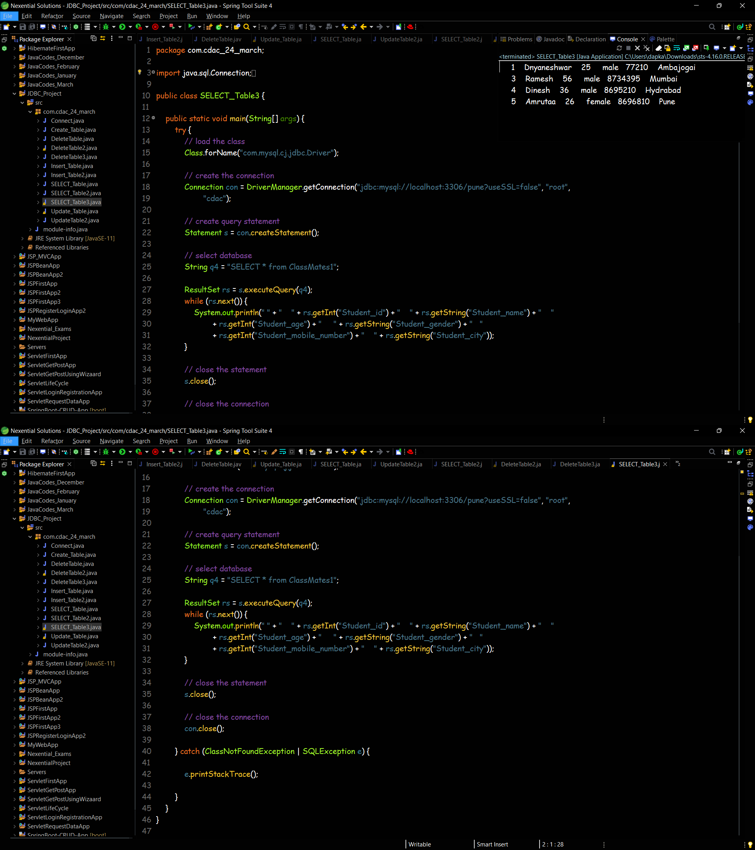

* SELECT row based on condition

package com.cdac_24_march;

import java.sql.Connection;

import java.sql.DriverManager;

import java.sql.ResultSet;

import java.sql.SQLException;

import java.sql.Statement;

public class SELECT_Table {

public static void main(String[] args) {

try {

// load the class

Class.forName("com.mysql.cj.jdbc.Driver");

// create the connection

Connection con = DriverManager.getConnection("jdbc:mysql://localhost:3306/pune?useSSL=false", "root",

"cdac");

// create query statement

Statement s = con.createStatement();

// select database

String q4 = "SELECT * from ClassMates1 WHERE Student_id = '" + "3" + "'";

ResultSet rs = s.executeQuery(q4);

if (rs.next()) {

System.out.println("Student details are : \n");

System.out.println("Student name : " + rs.getString(2));

System.out.println("Student age : " + rs.getInt(3));

System.out.println("Student gender : " + rs.getString(4));

System.out.println("Student mobile number : " + rs.getInt(5));

System.out.println("Student city : " + rs.getString(6));

} else {

System.out.println("No such student available");

}

// close the statement

s.close();

// close the connection

con.close();

} catch (ClassNotFoundException | SQLException e) {

e.printStackTrace();

}

}

}

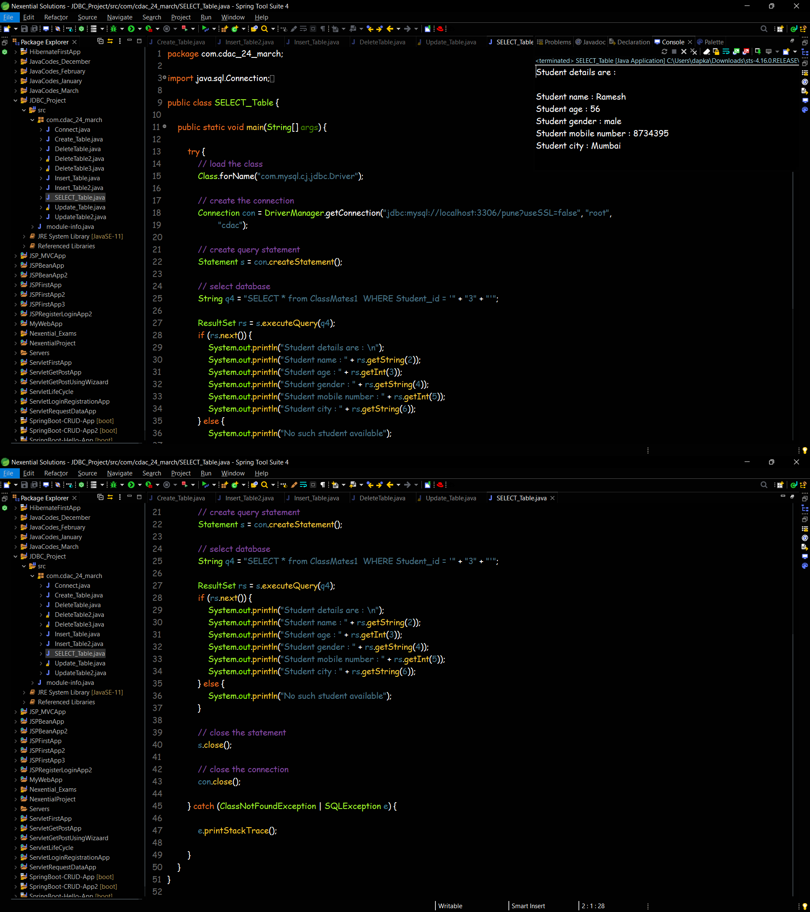

* SELECT row based on  getting data from user using scanner

package com.cdac_24_march;

import java.sql.Connection;

import java.sql.DriverManager;

import java.sql.ResultSet;

import java.sql.SQLException;

import java.sql.Statement;

import java.util.Scanner;

public class SELECT_Table2 {

public static void main(String[] args) {

Scanner sc = new Scanner(System.in);

System.out.println("Enter the id you want to select ");

int Student_id = sc.nextInt();

try {

// load the class

Class.forName("com.mysql.cj.jdbc.Driver");

// create the connection

Connection con = DriverManager.getConnection("jdbc:mysql://localhost:3306/pune?useSSL=false", "root",

"cdac");

// create query statement

Statement s = con.createStatement();

// select database

String q4 = "SELECT * from ClassMates1 WHERE Student_id = '" + Student_id + "'";

ResultSet rs = s.executeQuery(q4);

if (rs.next()) {

System.out.println("Student details are : \n");

System.out.println("Student name : " + rs.getString(2));

System.out.println("Student age : " + rs.getInt(3));

System.out.println("Student gender : " + rs.getString(4));

System.out.println("Student mobile number : " + rs.getInt(5));

System.out.println("Student city : " + rs.getString(6));

} else {

System.out.println("No such student available");

}

// close the statement

s.close();

// close the connection

con.close();

} catch (ClassNotFoundException | SQLException e) {

e.printStackTrace();

}

sc.close();

}

}

